Fakultet za poslovne studije i pravo
Univerzitet „Union – Nikola Tesla“, Beograd

Zvanje. ime i prezime autora

NASLOV I PODNASLOV

Beograd, 2022.

Naslov i podnaslov (tip publikacije: monografija ili udžbenik)

Autor
Xxxx

Izdavač
Fakultet za poslovne studije i pravo
Univerzitet „Union – Nikola Tesla“, Beograd

Za izdavača
Prof. dr Milan Radosavljević
Dekan Fakulteta za poslovne studije i pravo

Glavni i odgovorni urednik
Emeritus prof. dr Života Radosavljević , Fakultet za poslovne studije i pravo

Recezenti
Ime i prezime
Ustanova
Ime i prezime
Ustanova
Ime i prezime
Ustanova

Odlukom NNV broj xx/xx od xxxxxx. godine odobreno je da se
“xxxxxx” koristi kao nastavno sredstvo. Ovo opunjava Fakultet u slučaju udžbenika

Tehnički urednik: prof. dr Mirjana Puharić

Lektura i korektura teksta: Autori

Tehnička obrada i dizajn korica: _______________

Štampa: Štamparija Draslar List, Beograd

Tiraž 50

Redakcija
Fakultet za poslovne studije i pravo – Beograd
Jurija Gagarina 149A, Novi Beograd, Srbija
www.fpsp.edu.rs , info@fpsp.edu.rs

ISBN

Softverski je provereno i potvrđeno autorstvo publikacije

© 2022., XXXX
Ova publikacija ne sme biti reprodukovana ni u delovima ni u celini,
bez izričite pisane saglasnosti autora ili izdavača

Introduction / preface (Style: heading 1)
These are the guidelines how to prepare a paper for publishing . They are written in the form at that is being described in this template:
- Paper format is printing ISO B5 (170 x 240 cm)
- Margins - mirror marins: top 2,7cm, inside 2,5cm, outside 2cm, bottom 1.5cm
Text is written with fotnt Minion Pro 11pt, justified, Paragraf: before 3ptm after 3pt, Style: Text
If you have to say something additionat to same reference or to some part of the text, use Footnotes.
- Title 1 (Style: heading 1)
In this part it is descibed how to insert Index for monograph publicaions. Index of term you can insert with few next steps described in the following link
- https://www.youtube.com/watch?v=gIT_ZeI4AS0&ab_channel=MrTsingo

1.1. Title 1.1. (Style: Heading 2)
In this section you can see example for inserting Table, center alignment.
Text is format minion Pro 10pt, cell is vertical alignment, center
 | Column 1 | Column 2 | Column 3
Row 1 | Text | Text | Text
Row 2 | Text | Text | Text
Row 3 | Text | Text | Text

Table 1: Sample table(Source: https://www.xxx.xx)

1.1.1. Title 1.1.1. (Style: Heading 3)
In this section you can see example for inserting pictures and figures, center alignment.
Each downloaded image, table, graph must have the source indicated in the signature of the image in parentheses. Look at Figure 1.
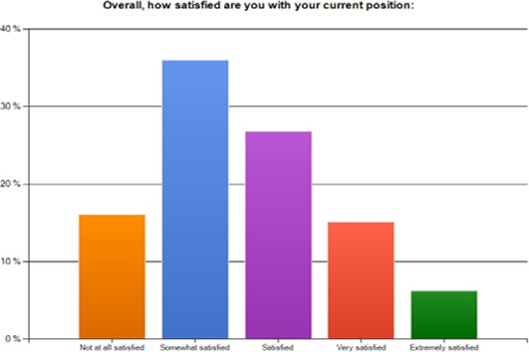
Figure 1: Figure for examlpe (Source: https://www.xxx.xx)

2. Title 2
In this section you can see example for inserting equation, center alignment.
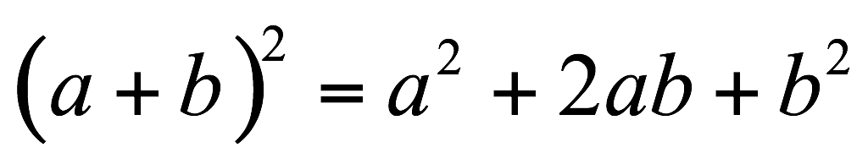 (1)

Conslusion
In the conclusion part we will explain you how to insert Reference/citation in APA style. How to insert biibliography referecnes lool on following link:
- https://www.youtube.com/watch?v=kEdpjsOEVVc
When quoting a source, the key part of the reference, part of the sentence, is taken by opening the quotation marks at the beginning of the quote and closing it at the end of the downloaded part, and then putting a footnote with details about the source.
Never download entire sentences, sections or pages.
Please note that this is necessary in order not to create a high percentage of plagiarism during Software Authorship Verification

References
- Best way to insert Table of Authorities is via:
  - Referecnces
  - Mark Citation (in text od exact position)
  - Insert Table of Authorities (in the end where references sholud ble placed)

- For a book: author(s), (year). book title (italic), page or chapter numbers, publisher, city. (Lynch, N. A. (1996) Distributed Algorithms, Morgan Kanfmann Publisher, San Francisco.)
- For a journal paper: author(s), (year). paper title, journal name (italic), volume and issue numbers, page numbers(inclusive). (Miriyala, K. and Harandi, M. T. (1991) Automatic derivation of formal software specifications from informal descriptions, IEE E Transactions on Software Engineering, Vol. 17, no.2, pp. 1126-1142.)
- For a proceedings paper or chapter in an edited book: author(s), (year). paper or chapter title, volume title (italic), editor(s), volume number (if applicable), publisher, city, page numbers (inclusive)
- For a Web article: author(s), (year). article title, Web site name, URL

INDEX OF TERMS

I
Index of terms 3

Footnotes are inserted from Word Reference tab – Insert Footnote

